J15. ROYAL PACKET NAVIGATION Co. SERIES. [date unknown]

Pu Koninklijke Paketvaart Maatschappij
F Coloured half-tone print enclosed in single line frame and title inside frame at lower side. This card has the lower edge either perforated (A) or rouletted (B).

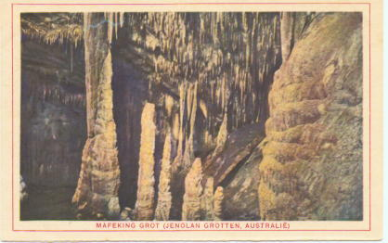

J15A.1 Mafeking Grot (Jenolan Grotten, Australie) H
J15B.1 Mafeking Grot (Jenolan Grotten, Australie) H
To our knowledge, this is the only cave card in the series.

